Jose Damian

Title of Program:

Battleship Game

Class Name:

CSC 17a

Introduction:

* This program is a 2 player game mode.
* The name of the program is Battleships Game.
* The game consists of code learned throughout the semester which includes arrays, functions and more.

Development Summary

* Lines of Code: around 250
* Comment Lines: 40
* Blank Lines:25
* Total lines in Source File:316

Game Rules

* 2 player game mode
* Each player will take turns entering coordinates
* Map cheating is allowed if #21 is entered cheat map will be revealed (example of actual game play):

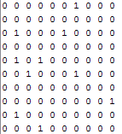

How to play

* Each player will have a map with 10 random ships

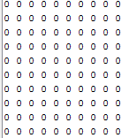

* The goal is to strike all 10 ships before the other player
* Each player will enter coordinates
* Entering coordinates example is below:

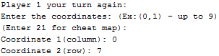

* If either player strikes a ship the number 0 will be replace with the number 2 implying a revealed shipped: (example below)

 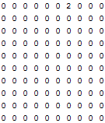

Term Definition:

|  |  |  |  |  |  |
| --- | --- | --- | --- | --- | --- |
| Code | | Purpose | | Example of Code in program | |
| * sif/else statement | | * if one statement is incorrect then it proceeds to the next one | | * if(A==21){ * Show()} * Else{ * Map();} | |
| * Do/while statement | | * Repeats code until statement is true | | * Do{cin>>c; * W }while (cin!=0); | |
| srand(time(0)) | | * Generates random time | | srand(time(0)) | |
| * /#include<????> | | * Libraries that access commands | | * Ex. #include <iostream> can access the in put and output library | |
| * //Function Prototypes | * S Stores function in prototypes | | * Void sShips(); * void sShips(); * int ships(){ * int c =0; * int x=0,y=0; * for(int i=0;i<10;i++){ * for (int j=0;j<10;j++){ * if(map[i][j]==1) * c++; * } * } * return c; * } | |
| * For statement | * Starts with a number and is usually incremented to stop at another number | | * for(int i=0;i<10;i++){ * cout<<”Map”;} | |
| Variables | * can be in the form of int,float,double,etc | | * int A; * Declares a variable | |
| bool | * For false or true statement | | * bool Strike2(int C, int D){ * if (map2[C][D] == 1){ * map2[C][D] = 2; * return true; * } * return false; * } | |

Flow Chart:

